# Al Hilaluddin 13020210070

#include <iostream> using namespace std;

int iterative (int arr[], int a, int b) {

int x = arr[b]; int y = (a - 1);

for (int i = a; i <= b - 1; i++) { if (arr[i] <= x) {

y++;

swap(arr[y], arr[i]);

}

}

swap(arr[y + 1], arr[b]); return (y + 1);

}

void quick_sort(int arr[], int a, int b) { int stack[b-a+1];

int top = -1; stack[++top]=a; stack[++top]=b;

while(top >= 0){

b = stack[top--];

a = stack[top--];

int p = iterative(arr, a, b); if(p-1>a){

stack[++top] = a; stack[++top] = p - 1;

}

if(p+1<b){

stack[++top] = p + 1; stack[++top] = b;

}

}

}

int rekursive (int ar[], int start, int end) { int pivot = ar[end];

int partitionIndex = start; for (int i=start; i<end; i++) {

if (ar[i] < pivot) {

swap (ar[i], ar[partitionIndex]); partitionIndex++;

}

}

swap (ar[partitionIndex], ar[end]); return partitionIndex;

}

void quickSort (int ar[], int start, int end) { if (start < end) {

int partitionIndex = iterative (ar,start,end); quickSort (ar,start,partitionIndex-1); quickSort (ar,partitionIndex+1,end);

}

}

int main(){

int n, pilih;

cout << "Masukkan Jumlah Data : " ; cin >> n ; int a[n];

for (int x=0 ; x<=n-1 ; x++) {

cout << "Masukkan Angka ke-" << x+1 << " : " ; cin >> a[x];

}

cout << endl;

cout << "Urutkan Data : " <<endl;

cout << "1. Iterative Quicksort :" << endl; cout << "2. Recursive Quicksort :" << endl;

cout << "Masukkan Pilihan [1..2] : "; cin >> pilih; cout<<endl;

if ( pilih == 1) {

cout << "Pengurutan Data Dengan Iterative Quicksort" << endl;

cout << "==========================================" << endl;

cout << "Data Sebelum Diurutkan : "; for(int x=0; x<n; x++) {

cout << a[x] << " ";

}

cout << endl;

quickSort(a,0,n-1);

cout << "Data Setelah Diurutkan : ";

for(int x=0; x<n; x++){

cout<<a[x]<<" ";

}

cout<<endl;

}

else if ( pilih == 2) {

cout << "Pengurutan Data Dengan Rekursive Quicksort" << endl;

cout << "==========================================" << endl;

cout << "Data Sebelum Diurutkan : ";

for(int x=0; x<n; x++) {

cout << a[x] << " ";

}

cout << endl; quickSort (a,0,n-1);

cout << "Data Setelah Diurutkan : ";

for(int x=0;x<n;x++) {

cout<<a[x]<<" ";

}

cout<<endl;

}

}

# Iterative Quicksort

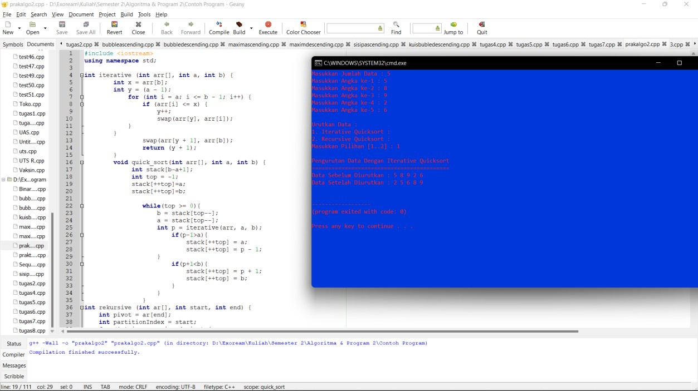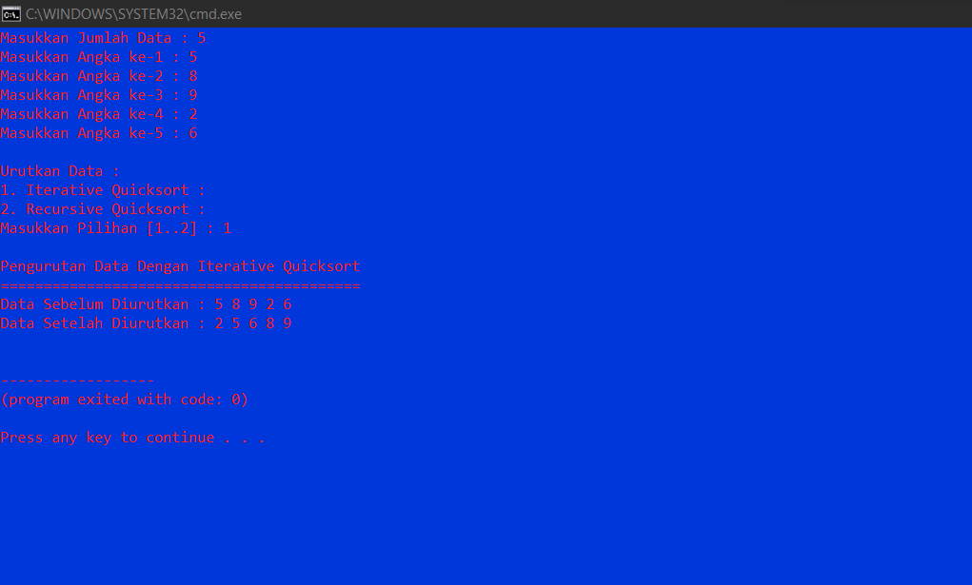

Recursive Quicksort

